Instructions:

* Open book
* Please no talking
* Instructor cannot assist
* The exam must be submitted before **9:00pm**

**There are 7 print screens each worth 14.2%**

**Based on Chapter 1-2**

1. Using the Scanner class, write a program that will ask the user the following: **name, address, city, and age,** then output the data.

**#1 print screen the output with the code below here**

**Based on Chapter 1-2**

1. Write an JOption class program that will allow the user to enter 3 numbers and output the total and average

**#2 print screen the output with the code below here**

**Based on Chapter 1-2**

1. Write an System.out program that will ask the user to enter 2 numbers and using the Math class output the highest and lowest numbers

**#3 print screen the output with the code below here**

**Based on Chapter 1-2**

1. Complete the following below: **note enter 100.00 for the purchase amount**

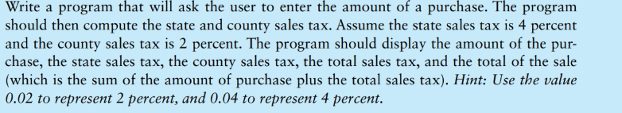

**#4 print screen the output with the code below here**

**Based on Chapter 1-2**

1. Complete the following below:

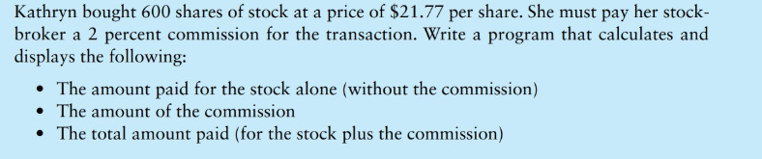

**#5 print screen the output with the code below here**

**Based on Chapter 3 (Decision Structures)**

1. Complete the following below:

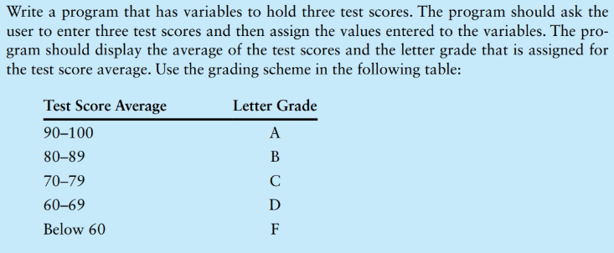

**#6 print screen the output with the code below here**

**Based on Chapter 4 (Loops)**

**Find and fix the error and print screen the output with code below**

**#7 print screen the output with the code below here**

**Submit this document to Module 8 Final Exam**